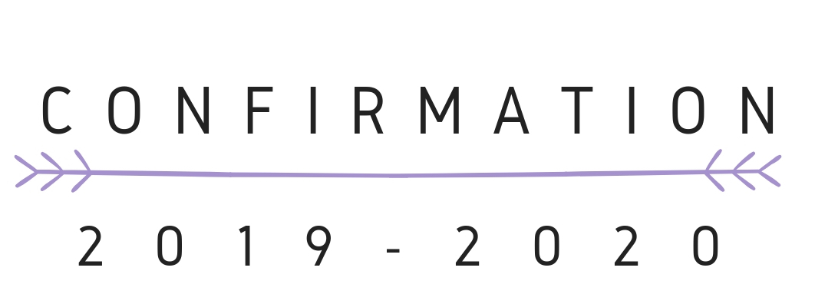

Welcome to Confirmation! We are embarking on a grand and audacious journey where we will learn about God, grapple with the awesome mysteries that have been revealed to us, and wrestle with some powerful questions. As we begin this collective effort, I just wanted to take a minute and express my excitement to be working with all of you. Sure, I may be the one teaching your lessons, but the nature of what we are doing will surely cause each one of you to be my teachers. Also, I am positive that you are all feeling a mix of wide-ranging emotions, be they excitement, trepidation, enthusiasm, or whatever else. Just know that we are in this together, all of us, and do not be afraid to voice questions, concerns, or areas of difficulty. Pastor Dale, Mrs. G, your mentors, your parents, and I are all here for you. Finally, please do not be intimidated by the amount of reading. Each chapter is only a handful of pages long and the prose is easy to follow. My advice is to simply not wait until the day before our classes meet to do the reading! Again, welcome!!!
- Pastor Ben
Schedule of Classes & FCC Services/Meetings
May 26, 2019
- Information Meeting
September 8, 2019
- Confirmation Potluck @ 5pm
Sept. 15 @ Dream Center:
- Class 1, 11:20am: Chapters 16 (Confirmation) & 1 (God)
Oct. 6 @ Dream Center:
- Class 2, 11:20am: Chapters 2 (Jesus), 7 (Sin), & 8 (Grace)
Oct. 20 @ Dream Center:
- Class 3, 11:20am: Chapters 3 (The Holy Spirit), 9 (The Church), & 14 (Baptism)
Nov. 3 @ Dream Center:
- Class 4, 11:20 am: Chapters 10 (Worship), 15 (Communion) & 13 (Music)
Nov. 17 @ Dream Center:
- Class 5, 11:20am am: Chapter 4 (Faith)
Dec. 8 @ Dream Center:
- Class 6, 11:20am: Chapter 17 (Favorite Bible Stories)
Jan. 5 @ Dream Center:
- Class 7, 11:20am: Chapters 5 (Doubt) & 12 (Prayer)
Jan. 26 @ Dream Center:
- Class 8, 11:20am: Chapter 18 (The Really Hard Parts of the Bible)
Feb. 9 @ Dream Center:
- Class 9, 11:20am: Chapters 6 (Suffering), 36 (Life After Death), & 1 Corinthians 15
Mar. 8 @ Dream Center:
- Class 10, 11:20am: Chapters 21 (Vocation) & 24 (God’s Call to You)
Mar. 22 @ Dream Center:
- Class 11, 11:20am: Chapter 37 (Other Religions)
March 29 – April 5 @ Associate Office by Appointment:
- Confirmand Grad Check
Apr. 23 (Thursday) @ Parish Hall:
- 7pm Faith Statements & Confirmation Dessert
Apr. 26: CONFIRMATION SUNDAY!
Schedule of Interfaith Visits
Oct. 13th @ Norwalk Baptist
- TIME TBD
Feb. 7th @ Temple Sinai
- TIME TBD
Mar. 14th @ Al Madany Islamic Center of Norwalk
- TIME TBD

